3GPP TSG RAN WG1 #120 R1-2500767
Athens, Greece, February 17th – 21st, 2025
Agenda Item: 9.1.2
Source: Apple Inc.
Title: Discussion on Specification Support for AI/ML-based positioning
Document for: Discussion/Decision

Introduction
In the Rel-19 Work Item on Artificial Intelligence (AI)/Machine Learning (ML) for NR Air Interface the following objective governing for positioning support was agreed on [1]:
- Positioning accuracy enhancements, encompassing [RAN1/RAN2/RAN3]:
  - Direct AI/ML positioning:
    - (1st priority) Case 1: UE-based positioning with UE-side model, direct AI/ML positioning
    - (2nd priority) Case 2b: UE-assisted/LMF-based positioning with LMF-side model, direct AI/ML positioning
    - (1st priority) Case 3b: NG-RAN node assisted positioning with LMF-side model, direct AI/ML positioning.
  - AI/ML assisted positioning
    - (2nd priority) Case 2a: UE-assisted/LMF-based positioning with UE-side model, AI/ML assisted positioning
    - (1st priority) Case 3a: NG-RAN node assisted positioning with gNB-side model, AI/ML assisted positioning.
  - Specify necessary measurements, signalling/mechanism(s) to facilitate LCM operations specific to the Positioning accuracy enhancements use cases, if any
  - Investigate and specify the necessary signalling of necessary measurement enhancements (if any)
  - Enabling method(s) to ensure consistency between training and inference regarding NW-side additional conditions (if identified) for inference at UE for relevant positioning sub use cases.

In this paper, we provide our views on Rel-19 AI/ML positioning based on the WID and the RAN guidance.

Specification Impact of AI/ML procedures

Measurements: Sample and Path
In RAN1 #119, the following agreement was made [10]:
Agreement
For the definition of sample-based measurement, for gNB/TRP measurement of an estimated channel response between a pair of UE and TRP, the starting time of the list of N_{t} consecutive samples is determined as follows.
- starting time = first detected path rounded down with timing granularity T.
Note: UE-side measurement is a separate discussion.

Agreement
For Rel-19 AI/ML based positioning, for Case 3b, in addition to path-based measurement that is referring to the measurement in the existing specifications (up to Rel-18), additionally support the following enhancement to the measurement,
- The measurement is composed of N_{t}' values of the estimated channel response in time domain. The N_{t}’ values are selected from a list of N_{t} consecutive channel response values, which have timing granularity T.
- The timing information for the N_{t}' values are reported with a timing granularity T, where T=2^{k}xT_{c}. k represents the timing reporting granularity factor. T_{c} is the basic time unit for NR.
  - The associated measurement (e.g., power if reported) corresponds to the measurement for the reported N_{t}' values.
- The timing information is defined relative to a reference time, same as the path-based measurement.
- The N_{t}’ selected time domain channel measurement values are expected to be those with the highest power.
- The starting time of the list of N_{t} consecutive values is determined as: starting time = first detected path rounded down with timing granularity T.
- LMF can signal parameter values of N_{t}, N_{t}', k to gNB via NRPPa. Candidate set values:
  - N_{t}'<=24. FFS: N_{t}' values.
  - N_{t} = {32, 64, 128}
  - FFS: k
  - The gNB/TRP may use different N_{t}', N_{t} and/or k values other than the signalled parameter for measurement reporting. In this case, it’s up to LMF implementation to process the reported measurement
- FFS: whether transmit offset from gNB to LMF
Note: measurement by UE is a separate discussion.
Note: the purpose of the time domain channel measurements, such as for Rel-19 AI/ML based positioning, is not specified

Specification Impact
For sample-based measurement, the following should be supported:
- Increase the number of additional paths supported (the value range of Nt) to [32, 64, 128].
- The samples are the Nt consecutive samples
- Set Nt’ to 9, 16 or 24
- The samples reported are the Nt’ strongest samples
- Support both absolute and differential RSRPP mapping for RSRPP values
- The measurement depends on the input type
  - Delay profile: timing information with no magnitude
  - Power Delay Profile: Timing information and RSPP
  - CIR: Timing information, RSPP and phase information
- Model input for UE feedback to LMF to support Case 2b should be identical to the existing agreement i.e. support sample and path-based measurement

Proposal 1: For sample-based measurement:
- Increase the number of additional paths supported (the value range of Nt) to 32, 64, 128
- Set Nt’ to 9, 16 or 32
- The samples reported are the Nt’ strongest samples

Proposal 2: Support both absolute and differential RSRPP mapping for RSRPP values
- The measurement depends on the input type
  - Delay profile: timing information with no magnitude
  - Power Delay Profile: Timing information and RSPP
  - CIR: Timing information, RSPP and phase information

Proposal 3
- Model input for UE feedback to LMF for Case 2b should be identical to the existing agreement i.e. support sample and path-based measurement.

Measurements: Types and Timing
In RAN1 #119, the following agreement was made [10]:
Agreement
For the definition of sample-based measurement, for gNB/TRP measurement of an estimated channel response between a pair of UE and TRP, the starting time of the list of N_{t} consecutive samples is determined as follows.
- starting time = first detected path rounded down with timing granularity T.
Note: UE-side measurement is a separate discussion.

Agreement
- The timing information is defined relative to a reference time, same as the path-based measurement.

Timing Measurement
On the reference time for UE channel measurements reported to the LMF, RAN1 to re-use the legacy reference time for UE side channel measurements as follows:
- Option 1: The reference time is T_{SubframeRxi}, as defined in TS 38.215, clause 5.1.29.
- Option 2: The reference time is T_{UE-TX}, as defined in TS 38.215, clause 5.1.30.

Option 1:
Definition | DL reference signal time difference (DL RSTD) is the DL relative timing difference between the Transmission Point (TP) [18] j and the reference TP i, defined as T_{SubframeRxj} – T_{SubframeRxi},  Where:  T_{SubframeRxj} is the time when the UE receives the start of one subframe from TP j.  T_{SubframeRxi} is the time when the UE receives the corresponding start of one subframe from TP i that is closest in time to the subframe received from TP j.  Multiple DL PRS resources can be used to determine the start of one subframe from a TP.  For frequency range 1, the reference point for the DL RSTD shall be the antenna connector of the UE. For frequency range 2, the reference point for the DL RSTD shall be the antenna of the UE.
Applicable for | RRC_CONNECTED,  RRC_INACTIVE,  RRC_IDLE

Option 2:
Definition | The UE Rx – Tx time difference is defined as T_{UE-RX} – T_{UE-TX}  Where:  T_{UE-RX} is the UE received timing of downlink subframe #i from a Transmission Point (TP) [18], defined by the first detected path in time.  T_{UE-TX} is the UE transmit timing of uplink subframe #j that is closest in time to the subframe #i received from the TP.  Multiple DL PRS or CSI-RS for tracking resources, as instructed by higher layers, can be used to determine the start of one subframe of the first arrival path of the TP. The time of the beginning of a subframe is determined by assuming the time durations of the OFDM symbols at the receiver are the same as defined in TS 38.211 [3].  For frequency range 1, the reference point for T_{UE-RX} measurement shall be the Rx antenna connector of the UE and the reference point for T_{UE-TX} measurement shall be the Tx antenna connector of the UE. For frequency range 2, the reference point for T_{UE-RX} measurement shall be the Rx antenna of the UE and the reference point for T_{UE-TX} measurement shall be the Tx antenna of the UE.
Applicable for | RRC_CONNECTED,  RRC_INACTIVE

We prefer option 1 with an additional report of the reference TRP for the model.

Proposal 4: On the reference time for UE channel measurements reported to the LMF, RAN1 to re-use the legacy reference time for UE side channel measurements as follows:
- Option 1: The reference time is T_{SubframeRxi}, as defined in TS 38.215, clause 5.1.29.
- Option 2: The reference time is T_{UE-TX}, as defined in TS 38.215, clause 5.1.30.
- We prefer at least option 1

Proposal 5:
- The starting time of the list of N_{t} consecutive samples for UE to support Case 2b should be identical to the existing agreement i.e. first detected path rounded down with timing granularity T.

Phase measurement for model input (CIR)
To motivate the need for CIR input, the following tables capture the performance of direct AI/ML based positioning by comparing sample-based and path-based feedback for CIR, PDP and DP model input at 100 MHz and 20 MHz for models of different complexity.

Table 1: Direct AI/ML Positioning: Evaluation results for AI/ML model deployed on UE/Network side, with CNN1, UE distribution area = 100x40 m, Bandwidth = 100 MHz
Model input | Model output | Label | Settings (e.g., drops, clutter param, mix) |  | Dataset size |  | AI/ML complexity |  | Horizontal pos. accuracy at CDF=90% (m) | Comments
 |  |  | Train | Test | Train | test | Model complexity | Computation complexity | AI/ML
CIR  Sample  [18,1,256,2] | UE coordinates  [1x2] | 2-D UE position 100% labeled | Drop 1 | Drop 2 | 47500 | 2500 | 1.48M | 2.75G | 0.7095 | CIR Sample based  100MHz  16.5393 samples
DP  Sample  [18,1,256,1] | UE coordinates  [1x2] | 2-D UE position 100% labeled | Drop 1 | Drop 2 | 47500 | 2500 | 1.48M | 2.75G | 0.8313 | DP Sample-based  100MHz  16.5393 samples
PDP  Sample  [18,1,256,1] | UE coordinates  [1x2] | 2-D UE position 100% labeled | Drop 1 | Drop 2 | 47500 | 2500 | 1.48M | 2.75G | 0.7331 | PDP Sample-based  100MHz  16.5393 samples
PDP  Path  [18,1,256,1] | UE coordinates  [1x2] | 2-D UE position 100% labeled | Drop 1 | Drop 2 | 47500 | 2500 | 1.48M | 2.75G | 1.0762 | PDP Path-based  100MHz  6.4214 samples
CIR  path  [18,1,256,2] | UE coordinates  [1x2] | 2-D UE position 100% labeled | Drop 1 | Drop 2 | 47500 | 2500 | 1.48M | 2.75G | 1.1351 | CIR Path-based  100MHz  6.4214 samples

Table 2: Direct AI/ML Positioning: Evaluation results for AI/ML model deployed on UE/Network side, with CNN2, UE distribution area = 100x40 m, Bandwidth =100 MHz

Model input | Model output | Label | Settings (e.g., drops, clutter param, mix) |  | Dataset size |  | AI/ML complexity |  | Horizontal pos. accuracy at CDF=90% (m) | Comments
 |  |  | Train | Test | Train | test | Model complexity | Computation complexity | AI/ML
CIR  Sample  [18,1,256,2] | UE coordinates  [1x2] | 2-D UE position 100% labeled | Drop 1 | Drop 2 | 47500 | 2500 | 12.37M | 103G | 0.5615 | CIR Sample based  100MHz  16.5393 samples
DP  Sample  [18,1,256,1] | UE coordinates  [1x2] | 2-D UE position 100% labeled | Drop 1 | Drop 2 | 47500 | 2500 | 12.37M | 103G | 0.6606 | DP Sample-based  100MHz  16.5393 samples
PDP  Sample  [18,1,256,1] | UE coordinates  [1x2] | 2-D UE position 100% labeled | Drop 1 | Drop 2 | 47500 | 2500 | 12.37M | 103G | 0.6645 | PDP Sample-based  100MHz  16.5393 samples
PDP  Path  [18,1,256,1] | UE coordinates  [1x2] | 2-D UE position 100% labeled | Drop 1 | Drop 2 | 47500 | 2500 | 12.37M | 103G | 0.6638 | PDP Path-based  100MHz  6.4214 samples
CIR  path  [18,1,256,2] | UE coordinates  [1x2] | 2-D UE position 100% labeled | Drop 1 | Drop 2 | 47500 | 2500 | 12.37M | 103G | 0.7009 | CIR Path-based  100MHz  6.4214 samples

Table 3: Direct AI/ML Positioning: Evaluation results for AI/ML model deployed on UE/Network side, with CNN1, UE distribution area = 100x40 m, Bandwidth=20 MHz

Model input | Model output | Label | Settings (e.g., drops, clutter param, mix) |  | Dataset size |  | AI/ML complexity |  | Horizontal pos. accuracy at CDF=90% (m) | Comments
 |  |  | Train | Test | Train | test | Model complexity | Computation complexity | AI/ML
CIR  Sample  [18,1,256,2] | UE coordinates  [1x2] | 2-D UE position 100% labeled | Drop 1 | Drop 2 | 47500 | 2500 | 1.48M | 2.75G | 1.0607 | CIR Sample based  100MHz  37.2749 samples
DP  Sample  [18,1,256,1] | UE coordinates  [1x2] | 2-D UE position 100% labeled | Drop 1 | Drop 2 | 47500 | 2500 | 1.48M | 2.75G | 1.0481 | DP Sample-based  100MHz  37.2749 samples
PDP  Sample  [18,1,256,1] | UE coordinates  [1x2] | 2-D UE position 100% labeled | Drop 1 | Drop 2 | 47500 | 2500 | 1.48M | 2.75G | 1.0723 | PDP Sample-based  100MHz  37.2749 samples
PDP  Path  [18,1,256,1] | UE coordinates  [1x2] | 2-D UE position 100% labeled | Drop 1 | Drop 2 | 47500 | 2500 | 1.48M | 2.75G | 3.8814 | PDP Path-based  100MHz  7.1352 samples
CIR  path  [18,1,256,2] | UE coordinates  [1x2] | 2-D UE position 100% labeled | Drop 1 | Drop 2 | 47500 | 2500 | 1.48M | 2.75G | 1.8345 | CIR Path-based  100MHz  7.1352 samples

To summarize the results, the relative performance between a CIR, PDP and DP measurement input may depend on parameters such as the complexity of the AI/ML model and the sensing bandwidth. There are scenarios in which the PDP as well (high complexity, high bandwidth in Table 1) and others in which it performs worse (high complexity, low bandwidth, small # of samples in Table 3. This could be because the sample resolution is worse than that of the 100 MHz bandwidth channel and as such, the path resolution does not capture the signature of the channel as well.

The key take-away from these results is that there is a need for specifying CIR as a model input for R19 AI/ML positioning.

However, CIR has a larger feedback size than either the PDP or the DP as an extra phase element may need to be signaled. This is not a problem in scenarios where the measurement and the inference are at the same entity but may result in higher overheads in the case that they are different or in the case of data collection for training or monitoring.

On the impact of transmitter and receiver implementation, non-idealities in the phase measurement such as initial phase mismatch may impact the performance of the system. To investigate this, we use the nitial phase mismatch modeled as (see TR 38.859):
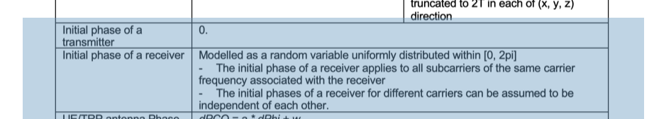

In the table below, we show the performance of AI/ML positioning with an initial phase mismatch between the transmitter and receiver:

Table 5: Direct AI/ML Positioning: Evaluation results for AI/ML model deployed on UE / Network side, with CNN1, UE distribution area = 100x40 m, Bandwidth = 20 MHz
Model input | Model output | Label | Settings (e.g., drops, clutter param, mix) |  | Dataset size |  | AI/ML complexity |  | Horizontal pos. accuracy at CDF=90% (m) | Comments
 |  |  | Train | Test | Train | test | Model complexity | Computation complexity | AI/ML
CIR  Sample  [18,1,256,2] | UE coordinates  [1x2] | 2-D UE position 100% labeled | No Mismatch | No Mismatch | 19000 | 1000 | 1.48M | 2.75G | 1.1876 | No error
CIR  Sample  [18,1,256,2] | UE coordinates  [1x2] | 2-D UE position 100% labeled | No Mismatch | Mismatch | 19000 | 1000 | 1.48M | 2.75G | 5.6919 | No generalization
CIR  Sample  [18,1,256,2] | UE coordinates  [1x2] | 2-D UE position 100% labeled | Mismatch | Mismatch | 19000 | 1000 | 1.48M | 2.75G | 1.3535 | Generalization
CIR  Sample  [18,1,256,2] | UE coordinates  [1x2] | 2-D UE position 100% labeled | Compensated | Compensated | 19000 | 1000 | 1.48M | 2.75G | 1.1986 | Compensation

Assume that the CIR is of the form 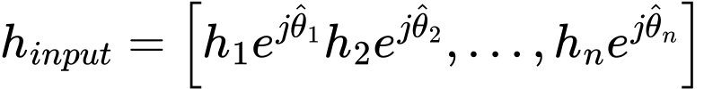, with the magnitude of a tap i is represented in the general form 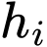 and the phase term of a tap i is represented in the general form 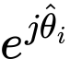 with the phase value of a tap of the form 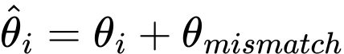, where 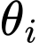 is a known phase and 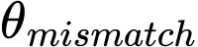 is the unknown phase mismatch. To eliminate the unknown  value, the original channel carrier wave information equation  may be multiplied by a conjugate of the phase term of one of the taps for example with tap i = 1 is used, this results in the equation where “*” represents a conjugate value), simplified as . This eliminates the mismatch and keeps the overall signature of the channel. The result here may be viewed as a mix of (1) a power delay profile (power and timing information only) on the first tap and (2) CIR (power, timing and phase information) on the additional taps, where the phase of the additional taps have been compensated to remove the effect of any phase mismatch

From the results, we can see that with phase mismatch between the transmitter and receiver, the accuracy of AI/ML based positioning degrades. However, by training the model with similar data, we can recover quite some of the performance loss.

On other aspects, to limit the overhead, a model may be able to support mixed input with CIR input for the TRPs closest and PDP/DP for TRPs further away as shown below:

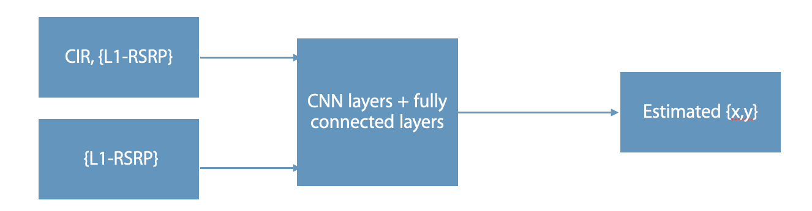

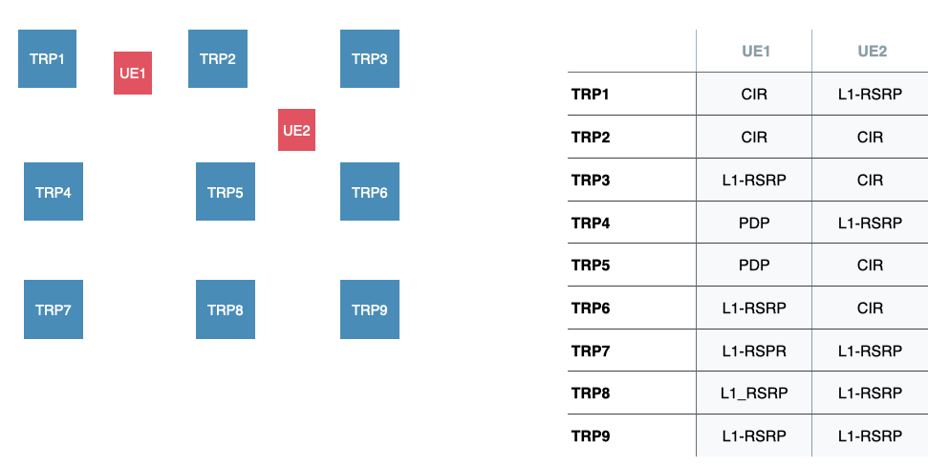

Proposal 6: On the use of CIR model input for AI/ML positioning:
  - The relative performance of CIR and PDP depends on the complexity of the AI/ML model, bandwidth and number of samples.
  - With phase mismatch between the transmitter and receiver, the accuracy of AI/ML based positioning degrades.
    - Option 1: This can be mitigated by training the model with data that suffers a similar mismatch.
    - Option 2: This can be mitigated by training the model with data that is compensated to remove the effect of the mismatch.

Proposal 7: On other aspects, limit the overhead, a model may be able to support mixed input with CIR input for the TRPs closest and PDP/DP for TRPs further away.

Proposal 8: RAN1 to support using phase information (in addition to timing information and power information) for determining model input (i.e. support CIR based model input).

Input and Output for Model Inference
In RAN1 #116, the following agreement was made [3]:
Agreement
For AI/ML assisted positioning Case 3a, at least LOS/NLOS indicator and/or timing information are supported for reporting.
- If LOS/NLOS indicator is reported, the indicator can be reported as soft indicator or hard indicator as defined in 38.214.
- If timing information is reported, the timing information at least can be reported via UL RTOA or gNB Rx-Tx time difference as defined in 38.215.
- Note: details of the report are pending further discussion.

Agreement
For AI/ML assisted positioning Case 2a, at least LOS/NLOS indicator and/or timing information are supported for reporting.
- If LOS/NLOS indicator is reported, the indicator can be reported as soft indicator or hard indicator as defined in 38.214.
- If timing information is reported, the timing information at least can be reported via DL RSTD or UE Rx-Tx time difference as defined in 38.215.
- Note: details of the report are pending further discussion.

In RAN1 #119, the following agreement was made [10]:
Conclusion
For measurement report of AI/ML assisted positioning Case 3a, regarding the report of LOS/NLOS indicator,
- LOS/NLOS indicator can’t be reported independently from other measurements

In current specification, the LOS/NLOS indicator is defined for the first path per TRP or per resource. For sample-based input, whether the LOS/NLOS indicator is defined as the 1st sample or a few samples corresponding to the first path can be further discussed.

For AI/ML assisted positioning, when the LOS/NLOS indicator is reported for Rel-19 Case 3a or Case 2a, and the other associated measurement (e.g., timing information) is obtained by legacy positioning methods, from RAN1 perspective,
- The LOS/NLOS indicator provides the likelihood of a line-of-sight propagation path for the channel measured over the resource for which the measurement is reported;
- The LOS/NLOS indicator can reuse the existing IE "LoS/NLoS Information" in 38.455, which can be soft indicator or hard indicator.

For AI/ML assisted positioning, when the LOS/NLOS indicator is reported for Rel-19 Case 3a or Case 2a, and the other associated measurement (e.g., timing information) is obtained by AI/ML positioning methods, from RAN1 perspective,
- The LOS/NLOS indicator provides the likelihood of a line-of-sight propagation path for the channel measured over the resource for which the measurement is reported;
- The LOS/NLOS indicator can reuse the existing IE "LoS/NLoS Information" in 38.455, which can be soft indicator or hard indicator.
- The report should also include an indicator that the timing was obtained by AI/ML

In RAN1 #119, the following agreement was made [10]:
For measurement report of AI/ML assisted positioning Case 3a, when timing information is reported from gNB to LMF, LMF shall be able to distinguish whether the timing information is obtained by legacy method or by Rel-19 method.
FFS: how to ensure that LMF can distinguish this

Proposal 9: For Rel-19 Case 3a and Case 2a, if the LOS/NLOS indicator is reported with other associated measurement (e.g. timing information) obtained by legacy positioning methods,
- the LOS/NLOS indicator provides the likelihood of a line-of-sight propagation path for the channel measured over the resource for which the measurement is reported
- The LOS/NLOS indicator can reuse the existing IE "LoS/NLoS Information" in 38.455/37.355, which can be soft indicator or hard indicator.

Proposal 10: For Rel-19 Case 3a and Case 2a, if the LOS/NLOS indicator is reported and the other associated measurement (e.g., timing information) is obtained by AI/ML positioning methods, from RAN1 perspective,
- The LOS/NLOS indicator provides the likelihood of a line-of-sight propagation path for the channel measured over the resource for which the measurement is reported;
- The LOS/NLOS indicator can reuse the existing IE "LoS/NLoS Information" in 38.455/37.355, which can be soft indicator or hard indicator.
- The report should also include an indicator that the other associated measurement was obtained by AI/ML

Data Collection: Training, Inference and Monitoring

Data Collection Overview
Data collection for model training, model inference and model monitoring may need to be enhanced. Each of these can be classified into a Part A for the measurement information, Part B for the ground truth information and assistance information to assist the specific LCM procedure.

In RAN1 #116-bis the following agreement was made [5]:
Agreement
For training data collection of AI/ML based positioning, the collected data sample can include the following components:
Part A:
- channel measurement
- quality indicator of channel measurement
- time stamp of channel measurement
Part B:
- ground truth label (or its approximation)
- quality indicator of label
- time stamp of label
Note: “Part A” and “Part B” terminologies are only for RAN1 discussion purpose, and may not be used in specification.
Note: contents in Part A and Part B may or may not be generated by different entities.
Note: Part A and/or Part B, and their contents may or may not apply for each case
FFS: detailed definition of channel measurement

In RAN1 #118-bis, the following FL proposal was discussed:
For training data collection of AI/ML based positioning Cases 1, from RAN1 perspective, when label reporting is applicable, quality indicator of label is represented using one of the following options. RAN1 study and select between Option 1 and Option 2.
- Option 1: reuse an existing IE. For each case, companies provide input on the existing IE to use.
- Option 2: define a new IE on UE location quality. Use hard (1 or 0) and soft values (0, 0.1, 0.2, …, 1.0), with value 1 indicate the highest quality.
  - Proponent companies provide information on how to determine the value, entity to generate the label quality, and the applicable signaling.

The quality of part A may be defined based on the type of input. In legacy positioning, the nr-PathQuality IE field specifies the target device′s best estimate of the quality of the detected timing of the additional path. It maps to a timing-quality field that provides an estimate of the uncertainty of the timing value for which the IE NR-TimingQuality is provided in units of metres. To update this parameter for AI/ML based positioning, the Part A quality may be mapped to a timing quality, a power quality and a phase quality depending on the type of input.

For part B, the quality of the ground truth label (if measurement is the LOS/NLOS) may be set as a value from 0 to 1. GT that may be linked to timing or position may use the legacy method.

The “Measurement time” (NRPPa) and UTC-time (LPP) are mandatorily included together with SFN time to ensure uniqueness of the time stamp.

We think that for a GT label based on a position or a timing, the legacy method e.g. an updated NR-TimingQuality IE, should be used. For LOS/NLOS, a new quality may be defined.

Proposal 11: For part A, the quality indicator of the channel may be mapped to a timing quality, a power quality and a phase quality depending on the type of input

Proposal 12: For part B, the quality of the ground truth label
- In the case that the ground truth is a timing or position value, RAN1 should use the legacy method e.g. an updated NR-TimingQuality IE.
- In the case of LOS/NLOS as an output, a new quality may be defined e.g. ranging from 0 to 1.

Proposal 13: The “Measurement time” (NRPPa) and UTC-time (LPP) are mandatorily included together with SFN time to ensure uniqueness of the time stamp.

Entities to generate measurements and labels
In RAN1 #116-bis and RAN1 #117, the following working assumptions made on entities to generate measurements and labels, should be agreed.

Working Assumption
For training data generation of AI/ML based positioning Case 1, the measurement and its related data (e.g., timestamp) are generated by PRU and/or Non-PRU UE.

Working Assumption
For training data generation of AI/ML based positioning Case 1, the label and its related data (e.g., time stamp) can be generated by:
- PRU
- Non-PRU UE with estimated location
- LMF
Note: transfer of the label and its related data is out of RAN1 scope.

Working Assumption
For training data generation of AI/ML based positioning Case 3b, the label and its related data (e.g., time stamp) can be generated by:
- PRU
- Non-PRU UE with estimated location
- LMF
Note: transfer of label and its related data is out of RAN1 scope.
Note: It is assumed that user data privacy of non-PRU UE is preserved.

Note: Previous related working assumption made in RAN1#116bis for training data generation of AI/ML based positioning Case 3b will not need to be confirmed.

Proposal 14: the working assumption on entities to generate measurements and labels in RAN1 #116bis and RAN1 #117 should be approved

Specification Impact
For data collection, the key specification impacts are in the transfer of the measurement data in case 2b (UE to LMF) and case 3b (gNB to LMF) for model inference and model monitoring. This requires an update to support CIR, PDP, and DP measurement data.

For model training, the following elements shall be specified:
- Part A: Measurement (corresponding to model input), Quality indicator (for and/or associated measurement at least for model training), Time Stamp
- Part B: Ground truth label, Quality indicator (for and/or associated with ground truth label at least for model training), Time Stamp
- Assistance Information: RS configuration(s), other necessary information (e.g., scenario identifier. LOS/NLOS condition, timing error, etc.)

For model inference, the following elements shall be specified:
- Part A: Measurement (corresponding to model input), Time stamp,
- Assistance Information: RS configuration(s), other necessary information (e.g., scenario identifier. LOS/NLOS condition, timing error, etc.)

For model monitoring, the following elements shall be specified:
- Part A: Measurement (corresponding to model input), Quality indicator (for and/or associated measurement at least for model monitoring), Time stamp
- Part B: Ground truth label, Quality indicator (for and/or associated with ground truth label at least for model monitoring), Time stamp
- Assistance Information: RS configuration(s), other necessary information (e.g., scenario identifier. LOS/NLOS condition, timing error, etc.). For example, a change in a TRP configuration known by the network could enable the UE to know that it should trigger the monitoring procedure.
- Additional specification is required to transfer ground truth labels, quality indicators and other necessary information from the measurement entity to the monitoring entity.

Proposal 15: For model training, the following elements shall be specified as part of the data collection procedure:
- Part A
  - Channel Measurement (corresponding to model input),
  - Quality indicator (for and/or associated with measurement at least for model training)
  - Time stamp (for and/or associated with measurement)
- Part B
  - Ground truth label,
  - Quality indicator (for and/or associated with ground truth label)
  - Time stamp (for and/or associated with ground truth label)
- Assistance Information

Proposal 16: For model inference, the following elements shall be specified as part of the model inference procedure:
- Part A
  - Measurement (corresponding to model input),
  - Time stamp,
- Assistance Information

Proposal 17: For model monitoring, the following elements shall be specified as part of the monitoring procedure:
- Part A:
  - Measurement (corresponding to model input),
  - Time stamp,
  - Quality indicator (for and/or associated with ground truth label and/or measurement at least for model monitoring),
- Part B
  - Ground truth label,
  - Quality indicator (for and/or associated with ground truth label and/or measurement at least for model training),
  - Time Stamp
- Assistance Information

Proposal 18: For data collection, the key specification impacts are in the transfer of the measurement data in case 2b (UE to LMF) and case 3b (gNB to LMF) for model inference and model monitoring.
- This requires an update to support CIR, PDP and DP measurement data.
- Additional specification is required to transfer ground truth labels, quality indicators and other necessary information from the measurement entity to the monitoring entity.

Assistance Information

For Rel-19 AI/ML positioning, the assistance data be signaled as assistance information or configured as part of the procedure.

The information assistance data may be sent for any one of the LCM stages. They may be:
- LCM procedure specific e.g. for data collection for training only, monitoring only, inference only
  - Signalling of assistance data may be Option A (UE initiated) and/or Option B (LMF initiated)
- For use across LCM procedures e.g. to ensure consistency between model training and model inference.

The assistance data may be unicast or broadcast to multiple entities.

Proposal 19: For Rel-19 AI/ML positioning, assistance data be signaled as assistance information (Network Assistance Information or UE-Assistance Information) or configured as part of the procedure.

Proposal 20: The information assistance data may be sent for any one of the LCM stages as
- LCM procedure specific e.g. for data collection for training only, monitoring only, inference only
  - Signalling of assistance data may be Option A (UE initiated) and/or Option B (LMF initiated)
- For use across LCM procedures e.g. to ensure consistency between model training and model inference.
- The assistance data may be unicast to a single entity or broadcast to multiple entities.

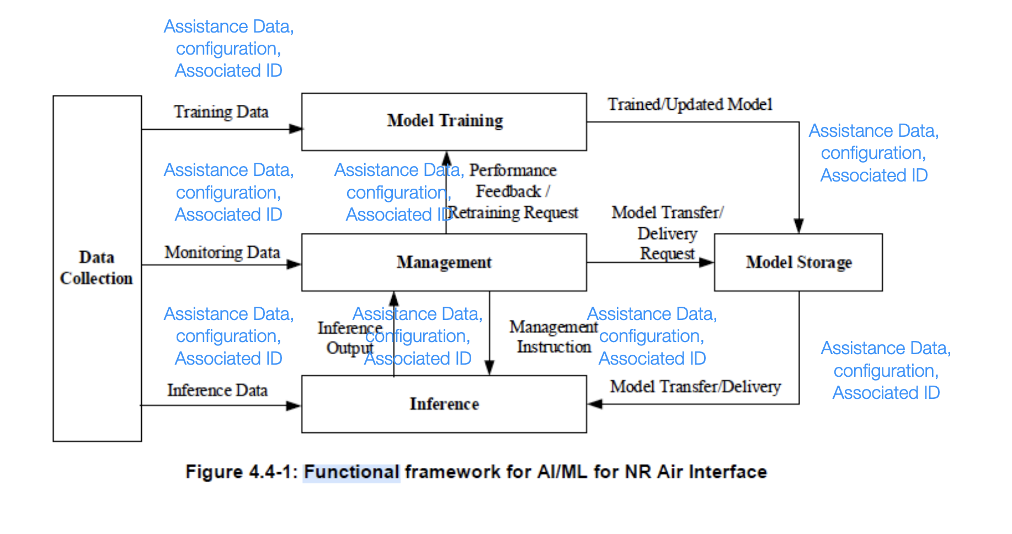
In RAN1 #119, the following agreement was made [10]:
Agreement
For AI/ML based positioning Case 1, all assistance information from legacy UE-based DL-TDOA, other than info #7, can be provided from LMF to UE. For info #7, RAN1 study, if necessary, choose one alternative from the following:
- Alternative 1. Info #7 is provided implicitly via associated ID.
  - Associated ID is signaled by LMF to indicate whether info #7 is consistent between training and inference.
- Alternative 2. Info #7 can be provided either implicitly or explicitly by LMF. Note: no UE capability is introduced on whether info #7 is provided implicitly or explicitly, and the UE can request info #7 to be provided explicitly or implicitly.
  - If provided implicitly, associated ID is signaled by LMF to indicate whether info #7 is consistent between training and inference.
- Alternative 3. Info #7 is not be provided from LMF to UE.
  - If info #7 is not provided, UE may assume info #7 is consistent between training and inference.
- Alternative 4. Info #7 is provided explicitly from LMF to UE.
7 | Geographical coordinates of the TRPs served by the gNB (include a transmission reference location for each DL-PRS Resource ID, reference location for the transmitting antenna of the reference TRP, relative locations for transmitting antennas of other TRPs)

Proposal 21: To ensure consistency between the LCM procedures,

- Alternative 2. Info #7 can be provided either implicitly or explicitly by LMF. Note: no UE capability is introduced on whether info #7 is provided implicitly or explicitly, and the UE can request info #7 to be provided explicitly or implicitly.
  - If provided implicitly, associated ID is signaled by LMF to indicate whether info #7 is consistent between training and inference

Proposal 22: For AI/ML based positioning Case 1, all assistance information from legacy UE-based DL-AoD can be provided from LMF to UE.

Proposal 23: the following new conditions may be signaled:
- Data Quality Conditions
  - Measurement data quality range (e.g. SNR/SINR range), (new)
  - label data quality range (e.g. mean label positioning error) (new)
  - Time range when data generated (new)
- Hardware Conditions
  - Network Synchronization Error (new)
  - Phase offset error (new)

Proposal 24: support a mechanism for the UE to indicate its preferred network-side conditions or specific UE side by a procedure similar to the “on-demand PRS”.

Model Monitoring
In model monitoring, the default option is for the monitoring to occur at the entity with the AI/ML model. However, there may be some cases in which a different entity may monitor the model. The monitoring entity may include a Statistics block/KPI generation/metric estimator, a Monitoring block/ Monitoring comparison entity with input from a triggering entity and output to a monitoring response entity. Ideally, these four entities should be in one device. However, if there is a need to separate them, then signaling will be required e.g. for case 1, the UE may perform the estimation, comparison and send a signal to the LMF for a response e.g. a fall back to non-AI/ML positioning.

Proposal 25: the default option is for the monitoring to occur at the entity with the AI/ML model.

Model Monitoring Procedure and Specification Impact
In RAN1 116-bis, the following agreements were made [5]:
Agreement
For model performance monitoring of AI/ML positioning Case 1, for model performance monitoring metric calculation in label-based model monitoring, study the feasibility, benefits, and potential specification impact of the following options with regard to how to generate information on ground truth label:
- Option A. The target UE side performs monitoring metric calculation.
  - Option A-1. At least information on ground truth label of the target UE is generated by LMF and provided to the target UE.
    - In one example, target UE and/or gNB sends measurement (e.g., legacy measurement) to LMF so that LMF can derive the information on ground truth label.
  - Option A-2. At least position calculation assistance data (e.g., existing information for UE-based positioning method) is provided from LMF to the target UE.
  - Option A-3. Reuse Rel-18 assistance data transfer framework from LMF to the target UE, where the PRU measurement (e.g., legacy measurement) and the corresponding PRU location are sent via LMF to the target UE.
  - Option A-4. PRU measurement (and the corresponding PRU location if not already known at the UE-side) are sent from PRU to the target UE side (e.g., target UE, OTT server).
    - Note: Option A-4 can be realized by implementation in a manner transparent to specification if the PRU sends information to the target UE side in a proprietary method.
- Option B. The LMF performs monitoring metric calculation.
  - Option B-1. at least inference result (i.e., the model output corresponding to target UE’s channel measurement) of the target UE is sent by the target UE to LMF.
  - Option B-2. PRU’s channel measurement is sent via LMF to the target UE, and the inference result (i.e., the model output corresponding to PRU’s channel measurement) is sent by the target UE to LMF.
Note: exact method to perform the monitoring metric calculation is up to implementation.
Note: Other options are not precluded

Proposal 26: RAN1 should support at least Option A-2, A-3 and B-1.

Proposal 27: To ensure the accuracy of the GT
- Step 1: use a LOS/NLOS identifier to identify >= 3 LOS links. Note that LOS probability may be used to derive the measurement quality.
- Step 2: use legacy positioning method to estimate GT position
- Step 3 (for case 2a): estimate GT timing for each of the LOS links based on estimated GT position

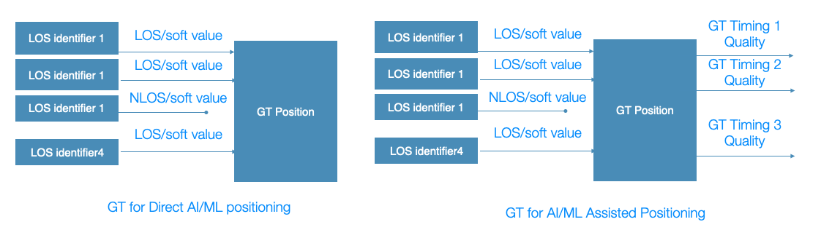
Figure 2: Generating GT from non-PRU UE for direct and assisted AI/ML positioning
In RAN1 116-bis the following agreements were made:
Agreement
For AI/ML positioning Case 3a, for model performance monitoring metric calculation in label-based model monitoring, study the feasibility of the following options. To provide information on how to generate information on ground truth label for each option.
- Option A. NG-RAN node performs monitoring metric calculation for its own model.
- Option B. LMF performs monitoring metric calculation for the model located at the NG-RAN node.
Note: Final selection of Option A and Option B is out of RAN1 scope, but RAN1 can make recommendation about the option(s), and potential support of Option A and/or Option B is pending RAN3 confirmation.
Note: Exact method to perform the monitoring metric calculation is up to implementation

For case 3a, the following additional options can be considered:

Proposal 28: For Case 3a Option A. NG-RAN node performs monitoring metric calculation for its own model.
- Option A-1. At least information on ground truth label of the target UE is generated by LMF and provided to the NG-RAN.
- Option A-2. Reuse Rel-18 assistance data transfer framework from LMF to the NG-RAN (based on NRPPa), where the PRU measurement (e.g., legacy measurement) and the corresponding PRU GT are sent via LMF to the NG-RAN.
  - Note as this is a PRU, the location is known by the LMF.
- NG-RAN node performs monitoring metric calculation for its own model in the LOS/NLOS use case.
- The NG-RAN node is not allowed to know the location of the non-PRU UEs connected to it. This is to maximize privacy for the non-PRU UEs connected to the NG-RAN node
- The NG-RAN node is not allowed to perform the monitoring metric calculation for the timing estimation use case.

Proposal 29: For Case 3a Option B. LMF performs monitoring metric calculation for the model located at the NG-RAN node
- Option B-1: at least inference result (i.e., the model output corresponding to target UE’s channel measurement) of the target UE is sent by the NG-RAN node to LMF.
  - In one example, target UE and/or gNB sends measurement (e.g., legacy measurement) to LMF so that LMF can derive the information on ground truth label. {non-PRU with estimated position)

- Option B-2: at least inference result (i.e., the model output corresponding to PRU channel measurement) “close” to the target UE is sent by the NG-RAN node to LMF.
  - In one example, PRU and/or gNB sends measurement (e.g., legacy measurement) to LMF so that LMF can derive the information on ground truth label.

Proposal 30: RAN1 should support at least Option A-2, and B-1.

Proposal 31: In the case on non-GT based monitoring, we have the following specification impact:

Case Specific non-GT Monitoring
 | Entity to derive monitoring metric (RAN1 #112, RAN1 #113) | Metric (2)  Measurements compared with training data.  Statistics of model output | signaling from LMF to facilitate the monitoring entity to derive the monitoring metric | signaling from monitoring entity to request measurement(s) | signaling for potential request /report of monitoring metric /monitoring decision
Case 1 | UE | Yes | Yes (assistance) | Yes | Inform network of model metric /decision
Case 3a | gNB, LMF (with GT) | Yes | Applicable if gNB | Yes | Option 1: no signaling (if gNB)  Option 2: inform other entities of model metric/decision e.g. gNB informs UE and/or LMF.
Case 3b | LMF | Yes | N/A | Yes | Inform gNB of monitoring decision (e.g. for input change)

In RAN2, the following agreements were made:
RAN2:
As a baseline, If the AIML based positioning method becomes non-applicable when LMF requests UE location estimation, UE cannot perform the AIML based positioning, and reply with LPP Providelocationinformation message with error cause. FFS if other fallback options are considered

Proposal 32: If the AIML based positioning method becomes non-applicable when LMF requests UE location estimation, and the UE cannot perform the AIML based positioning, RAN2 should allow for fallback to legacy based on UE-capability.

LCM Discussion
The concept/terminology of functionality should be clarified:

Proposal 33: The concept of functionality in AI/ML based positioning may be defined as follows:
- The concept/terminology “functionality” of Supported functionalities may refer to UE-capability information/parameters i.e., Rel-19 AI/ML-enabled Features/FGs
- The concept/terminology “functionality” of Applicable functionalities may refer to unsolicited UE capability report mechanism in LPP to report the applicable functionality in both “proactive” and “reactive” for inference configuration or a set of inference related parameters
- The Activated functionalities may be enabled based on step 5 i.e. The LMF requests the inferred location information using the LPP request location information message

Conclusion
In this contribution, we provided our views on use cases and potential specification impacts on the enhancement on AI/ML for positioning accuracy enhancement. Based on the discussion, we have the following proposals:

Measurements: Sample and Path:
Proposal 1: For sample-based measurement:
- Increase the number of additional paths supported (the value range of Nt) to 32, 64, 128
- Set Nt’ to 9, 16 or 32
- The samples reported are the Nt’ strongest samples

Proposal 2: Support both absolute and differential RSRPP mapping for RSRPP values
- The measurement depends on the input type
  - Delay profile: timing information with no magnitude
  - Power Delay Profile: Timing information and RSPP
  - CIR: Timing information, RSPP and phase information

Proposal 3
- Model input for UE feedback to LMF for Case 2b should be identical to the existing agreement i.e. support sample and path-based measurement.

Measurements: Types and Timing
Proposal 4: On the reference time for UE channel measurements reported to the LMF, RAN1 to re-use the legacy reference time for UE side channel measurements as follows:
- Option 1: The reference time is T_{SubframeRxi}, as defined in TS 38.215, clause 5.1.29.
- Option 2: The reference time is T_{UE-TX}, as defined in TS 38.215, clause 5.1.30.
- We prefer at least option 1

Proposal 5:
- The starting time of the list of N_{t} consecutive samples for UE to support Case 2b should be identical to the existing agreement i.e. first detected path rounded down with timing granularity T.

Proposal 6: On the use of CIR model input for AI/ML positioning:
  - The relative performance of CIR and PDP depends on the complexity of the AI/ML model, bandwidth and number of samples.
  - With phase mismatch between the transmitter and receiver, the accuracy of AI/ML based positioning degrades.
    - Option 1: This can be mitigated by training the model with data that suffers a similar mismatch.
    - Option 2: This can be mitigated by training the model with data that is compensated to remove the effect of the mismatch.

Proposal 7: On other aspects, limit the overhead, a model may be able to support mixed input with CIR input for the TRPs closest and PDP/DP for TRPs further away.

Proposal 8: RAN1 to support using phase information (in addition to timing information and power information) for determining model input (i.e. support CIR based model input).

Model Inference: Input and Output
Proposal 9: For Rel-19 Case 3a and Case 2a, if the LOS/NLOS indicator is reported with other associated measurement (e.g. timing information) obtained by legacy positioning methods,
- the LOS/NLOS indicator provides the likelihood of a line-of-sight propagation path for the channel measured over the resource for which the measurement is reported
- The LOS/NLOS indicator can reuse the existing IE "LoS/NLoS Information" in 38.455/37.355, which can be soft indicator or hard indicator.

Proposal 10: For Rel-19 Case 3a and Case 2a, if the LOS/NLOS indicator is reported and the other associated measurement (e.g., timing information) is obtained by AI/ML positioning methods, from RAN1 perspective,
- The LOS/NLOS indicator provides the likelihood of a line-of-sight propagation path for the channel measured over the resource for which the measurement is reported;
- The LOS/NLOS indicator can reuse the existing IE "LoS/NLoS Information" in 38.455/37.355, which can be soft indicator or hard indicator.
- The report should also include an indicator that the other associated measurement was obtained by AI/ML

Data Collection
Proposal 11: For part A, the quality indicator of the channel may be mapped to a timing quality, a power quality and a phase quality depending on the type of input

Proposal 12: For part B, the quality of the ground truth label
- In the case that the ground truth is a timing or position value, RAN1 should use the legacy method e.g. an updated NR-TimingQuality IE.
- In the case of LOS/NLOS as an output, a new quality may be defined e.g. ranging from 0 to 1.

Proposal 13: The “Measurement time” (NRPPa) and UTC-time (LPP) are mandatorily included together with SFN time to ensure uniqueness of the time stamp.

Proposal 14: the working assumption on entities to generate measurements and labels in RAN1 #116bis and RAN1 #117 should be approved

Proposal 15: For model training, the following elements shall be specified as part of the data collection procedure:
- Part A
  - Channel Measurement (corresponding to model input),
  - Quality indicator (for and/or associated with measurement at least for model training)
  - Time stamp (for and/or associated with measurement)
- Part B
  - Ground truth label,
  - Quality indicator (for and/or associated with ground truth label)
  - Time stamp (for and/or associated with ground truth label)
- Assistance Information

Proposal 16: For model inference, the following elements shall be specified as part of the model inference procedure:
- Part A
  - Measurement (corresponding to model input),
  - Time stamp,
- Assistance Information

Proposal 17: For model monitoring, the following elements shall be specified as part of the monitoring procedure:
- Part A:
  - Measurement (corresponding to model input),
  - Time stamp,
  - Quality indicator (for and/or associated with ground truth label and/or measurement at least for model monitoring),
- Part B
  - Ground truth label,
  - Quality indicator (for and/or associated with ground truth label and/or measurement at least for model training),
  - Time Stamp
- Assistance Information

Proposal 18: For data collection, the key specification impacts are in the transfer of the measurement data in case 2b (UE to LMF) and case 3b (gNB to LMF) for model inference and model monitoring.
- This requires an update to support CIR, PDP and DP measurement data.
- Additional specification is required to transfer ground truth labels, quality indicators and other necessary information from the measurement entity to the monitoring entity.

Assistance Information
Proposal 19: For Rel-19 AI/ML positioning, assistance data be signaled as assistance information (Network Assistance Information or UE-Assistance Information) or configured as part of the procedure.

Proposal 20: The information assistance data may be sent for any one of the LCM stages as
- LCM procedure specific e.g. for data collection for training only, monitoring only, inference only
  - Signalling of assistance data may be Option A (UE initiated) and/or Option B (LMF initiated)
- For use across LCM procedures e.g. to ensure consistency between model training and model inference.
- The assistance data may be unicast to a single entity or broadcast to multiple entities.

Proposal 21: To ensure consistency between the LCM procedures,

- Alternative 2. Info #7 can be provided either implicitly or explicitly by LMF. Note: no UE capability is introduced on whether info #7 is provided implicitly or explicitly, and the UE can request info #7 to be provided explicitly or implicitly.
  - If provided implicitly, associated ID is signaled by LMF to indicate whether info #7 is consistent between training and inference

Proposal 22: For AI/ML based positioning Case 1, all assistance information from legacy UE-based DL-AoD can be provided from LMF to UE.

Proposal 23: the following new conditions may be signaled:
- Data Quality Conditions
  - Measurement data quality range (e.g. SNR/SINR range), (new)
  - label data quality range (e.g. mean label positioning error) (new)
  - Time range when data generated (new)
- Hardware Conditions
  - Network Synchronization Error (new)
  - Phase offset error (new)

Proposal 24: support a mechanism for the UE to indicate its preferred network-side conditions or specific UE side by a procedure similar to the “on-demand PRS”.

Model Monitoring
Proposal 25: the default option is for the monitoring to occur at the entity with the AI/ML model.

Proposal 26: RAN1 should support at least Option A-2, A-3 and B-1.

Proposal 27: To ensure the accuracy of the GT
- Step 1: use a LOS/NLOS identifier to identify >= 3 LOS links. Note that LOS probability may be used to derive the measurement quality.
- Step 2: use legacy positioning method to estimate GT position
- Step 3 (for case 2a): estimate GT timing for each of the LOS links based on estimated GT position

Proposal 28: For Case 3a Option A. NG-RAN node performs monitoring metric calculation for its own model.
- Option A-1. At least information on ground truth label of the target UE is generated by LMF and provided to the NG-RAN.
- Option A-2. Reuse Rel-18 assistance data transfer framework from LMF to the NG-RAN (based on NRPPa), where the PRU measurement (e.g., legacy measurement) and the corresponding PRU GT are sent via LMF to the NG-RAN.
  - Note as this is a PRU, the location is known by the LMF.
- NG-RAN node performs monitoring metric calculation for its own model in the LOS/NLOS use case.
- The NG-RAN node is not allowed to know the location of the non-PRU UEs connected to it. This is to maximize privacy for the non-PRU UEs connected to the NG-RAN node
- The NG-RAN node is not allowed to perform the monitoring metric calculation for the timing estimation use case.

Proposal 29: For Case 3a Option B. LMF performs monitoring metric calculation for the model located at the NG-RAN node
- Option B-1: at least inference result (i.e., the model output corresponding to target UE’s channel measurement) of the target UE is sent by the NG-RAN node to LMF.
  - In one example, target UE and/or gNB sends measurement (e.g., legacy measurement) to LMF so that LMF can derive the information on ground truth label. {non-PRU with estimated position)

- Option B-2: at least inference result (i.e., the model output corresponding to PRU channel measurement) “close” to the target UE is sent by the NG-RAN node to LMF.
  - In one example, PRU and/or gNB sends measurement (e.g., legacy measurement) to LMF so that LMF can derive the information on ground truth label.

Proposal 30: RAN1 should support at least Option A-2, and B-1.

Proposal 31: In the case on non-GT based monitoring, we have the following specification impact:

Case Specific non-GT Monitoring
 | Entity to derive monitoring metric (RAN1 #112, RAN1 #113) | Metric (2)  Measurements compared with training data.  Statistics of model output | signaling from LMF to facilitate the monitoring entity to derive the monitoring metric | signaling from monitoring entity to request measurement(s) | signaling for potential request /report of monitoring metric /monitoring decision
Case 1 | UE | Yes | Yes (assistance) | Yes | Inform network of model metric /decision
Case 3a | gNB, LMF (with GT) | Yes | Applicable if gNB | Yes | Option 1: no signaling (if gNB)  Option 2: inform other entities of model metric/decision e.g. gNB informs UE and/or LMF.
Case 3b | LMF | Yes | N/A | Yes | Inform gNB of monitoring decision (e.g. for input change)

Proposal 32: If the AIML based positioning method becomes non-applicable when LMF requests UE location estimation, and the UE cannot perform the AIML based positioning, RAN2 should allow for fallback to legacy based on UE-capability.

Functionality and Model-ID based LCM
Proposal 33: The concept of functionality in AI/ML based positioning may be defined as follows:
- The concept/terminology “functionality” of Supported functionalities may refer to UE-capability information/parameters i.e., Rel-19 AI/ML-enabled Features/FGs
- The concept/terminology “functionality” of Applicable functionalities may refer to unsolicited UE capability report mechanism in LPP to report the applicable functionality in both “proactive” and “reactive” for inference configuration or a set of inference related parameters
- The Activated functionalities may be enabled based on step 5 i.e. The LMF requests the inferred location information using the LPP request location information message

References
- RP-234039, New WID on Artificial Intelligence (AI)/Machine Learning (ML) for NR Air Interface, December 2023, Qualcomm
- TR 38.843, Study on AI/ML for NR air interface, Nov 2023
- Chairman’s Notes, RAN1 #116, Athens, Greece, February 2024
- R1-2401825, Summary #2 of specification support for positioning accuracy enhancement, Ericsson, Athens, Greece, February 2024
- Chairman’s Notes, RAN1 #116-bis, Changsha, China, April 2024
- Chairman’s Notes, RAN1 #117, Fukuoka, Japan, May 2024
- Chairman’s Notes, RAN1 #118, Maastricht ,Netherlands, August 2024
- Moderator's summary on offline discussion about non-RAN2 aspects on REL-19 WI NR_AIML_Air Motivation, Melbourne, Australia, September 2024
- Chairman’s Notes, RAN1 #118-bis, Hefei, China, October 2024
- Chairman’s Notes, RAN1 #119, Orlando, USA, November 2024

